Static block

1. Static block is executed at the time of class loading. Hence, at the time of class loading, if we want to perform any activity, we have to define that inside static block.
2. **Application of Static Block?**
   1. **Example 01**: At the time of java class loading, the corresponding native library should be loaded. Hence, we have to define this activity inside static block.  
      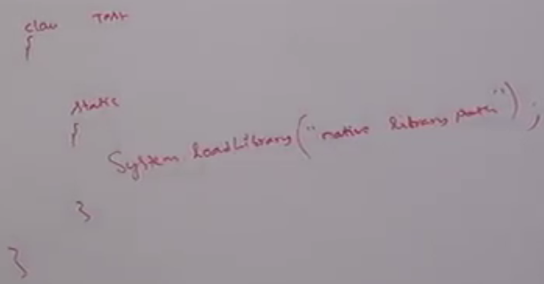  
      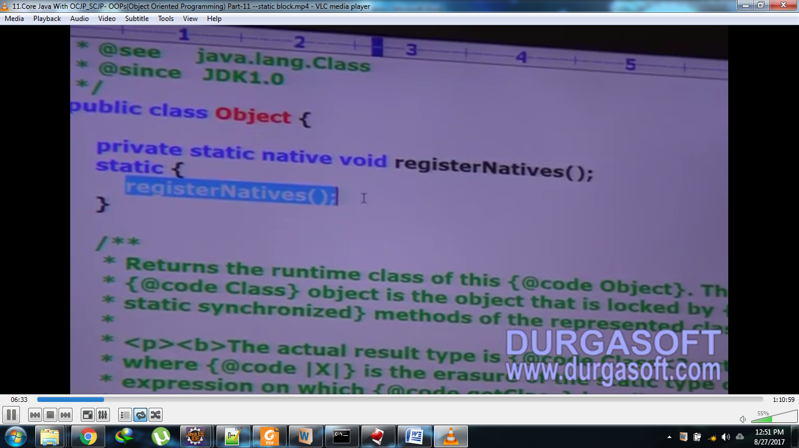  
      In **Object class**, there are many methods which are **native**🡪 hashCode(), wait()  
      In **Thread class**, There are many methods which are **native**🡪 start()
   2. **Example 02:** After loading every DB driver class, we have to register that driver class with DriverManager(C). But inside Database Driver class, there is **static block** to perform this activity. So we are not responsible to register explicitly.   
      class DBDriver{  
       static{  
       //Register this driver with driver manager.   
       }  
      }
3. **NOTE:** Within a class, we can declare any number of static blocks but all these static blocks will be executed from top to bottom.
4. **Without executing main(), is it possible to print some statements to the console?**
   1. Yes, By using static block.  
      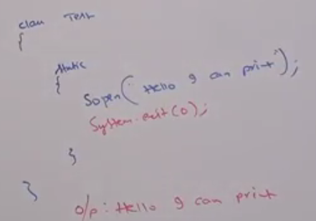
5. **Without main() and static block, is it possible to print some statements to the console?**
   1. 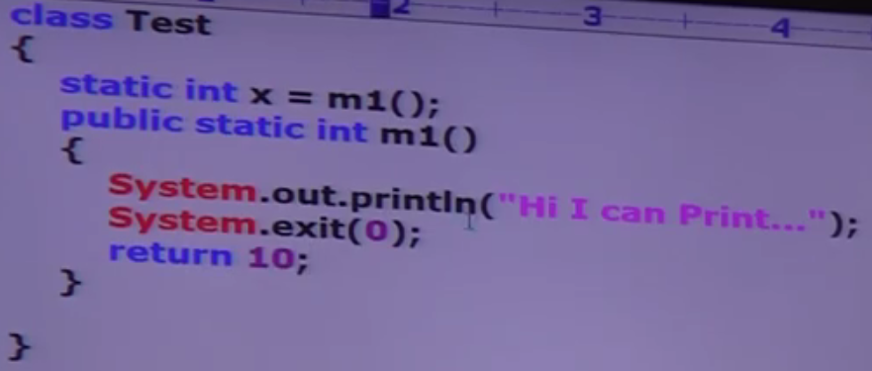  
      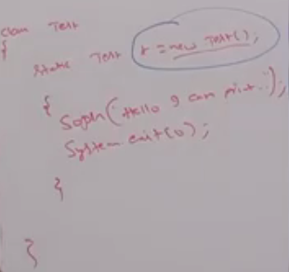

Initializing static variable with static method return value wherein we will output on screen

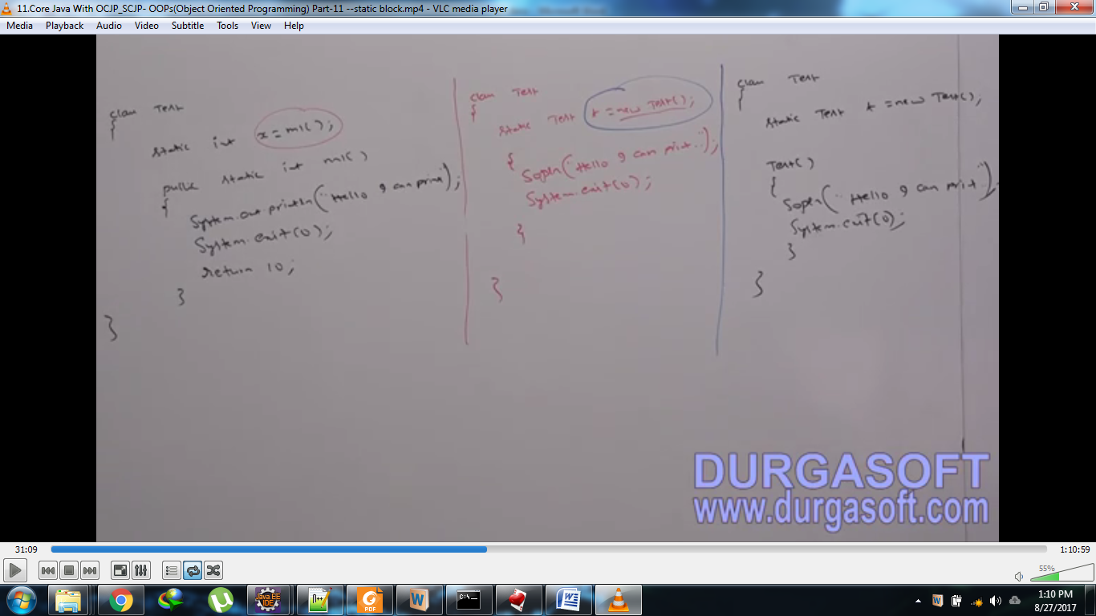

initializing static variable with new instance variable and so instance block and constructor will be executed where we can write output statements

1. **NOTE:** From 1.7 onwards, it’s impossible to print some statements on the console without writing main().

Static control flow in Parent-to-Child Relationship

1. **Rules**
   1. Identification of static members from parent-to-child.
   2. Execution of static variable assignment and static blocks from parent-to-child
   3. Execution of main()
2. 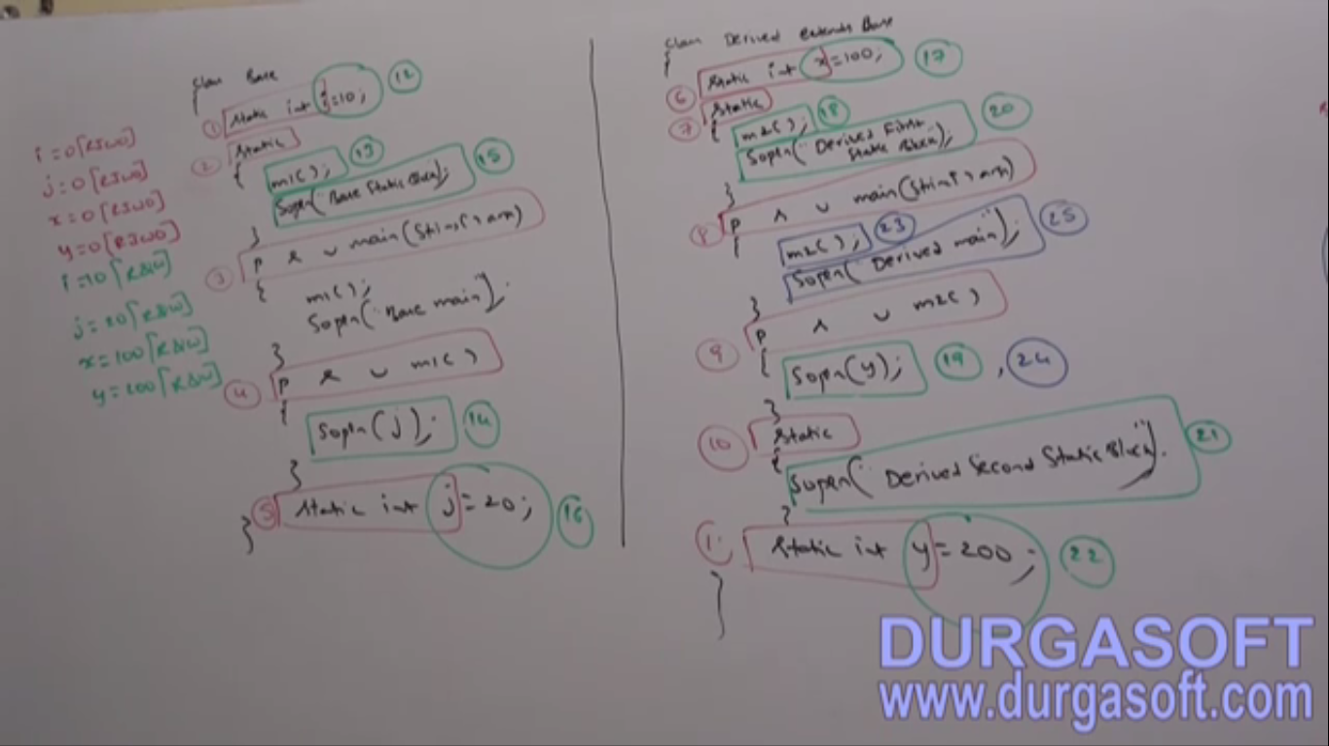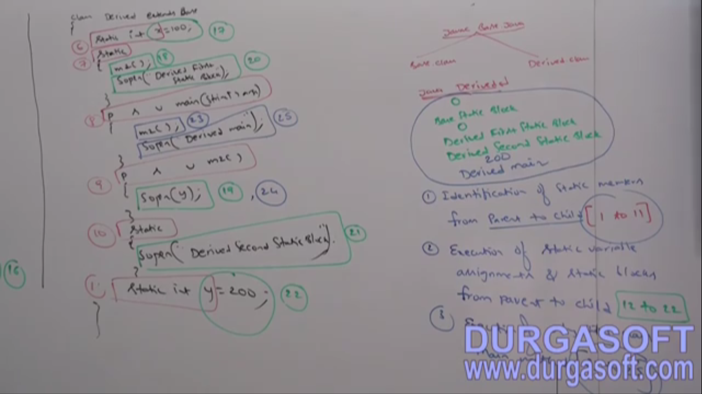  
   **NOTE**: Whenever we are loading Parent class, child class is not loaded by default because child class members are not available by default to the parent but parent class members are available to the child class.